5 February 2024 Excise Increase
Resource Handbook

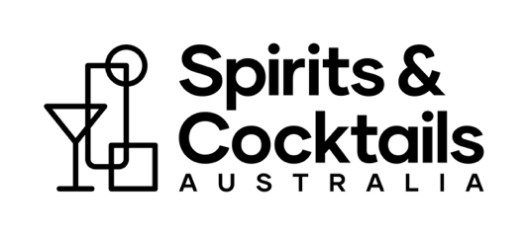
Prepared by

Background

Australia’s alcohol taxation system is illogical, incoherent, and discriminatory regarding spirits.

The alcohol contained in beer, wine or spirits is exactly the same substance. Yet, there are massive discrepancies in the tax rates that apply in – and even within – each alcohol category.

Wine and other fruit-based alcohol products are taxed based on their wholesale price, rather than alcohol content. Other alcohol products are taxed on a volumetric basis, with vastly different rates applying to beer and spirits, and the sub-categories they respectively contain.

There is no health rationale for these different tax rates. The breathalyser doesn’t discriminate between different forms of alcohol, so nor should the tax system.

Further, this tax system was largely designed last century. It therefore fails to recognise the changing behaviours of consumers in Australia, where the rate of alcohol consumption is at a 50-year low. Australian consumers today are evidently drinking less, but better.
The Australian Distillers Association and Spirits & Cocktails Australia believe alcohol is alcohol.

Our ultimate goal is a fairer and more equitable excise rate for spirits that doesn’t put such an onerous tax burden on the industry.
We are campaigning for a staged approach to taxation reform that is based on clearly established public policy objectives that benefit the Australian community.
The Federal Government can no longer ignore the negative impacts that the current alcohol tax system is having on spirits manufacturers, consumers, and our entire supply chain stretching from grain to glass.

We are calling for spirits excise to be urgently frozen at its current rate. This first stage of our proposed reforms would be a precursor for industry and Government to consider more substantive changes.

Freezing spirits excise would give the industry temporary relief in the current economic environment, which is already severely challenging without the pressure of automatic indexation to CPI every six months.

An unsustainable situation

On 5 February 2024, the excise rate for spirits was increased to $101.85 per pure litre of alcohol, following the latest six-monthly indexation to CPI.

This latest increase to the world’s third highest spirits tax is unconscionable under the current economic conditions confronting Australian spirits manufacturers. The entire industry must work together to raise awareness among politicians, customers, communities and staff of the impact that high spirits excise has on the growth and sustainability of the Australian spirits industry.

The automatic indexation of spirits tax every six months is now under unprecedented scrutiny as a cost of living issue. The media and the public have cottoned on to the fact that alcohol tax increases are contributing to inflation and eroding their discretionary income, because income tax is not indexed to inflation.

We must seize this opportunity and maintain pressure on the Government to take action on spirits tax.

What are we calling on the Government to do?

Australian Distillers Association and Spirits & Cocktails Australia are calling on the Federal Government to freeze spirits excise at the 5 February 2024 rate for two years.

Alcohol duty is currently frozen in the UK and Canada, establishing a precedent for this policy position.

Freezing spirits excise will provide immediate relief to spirits producers, allowing time for industry and government to work together to get the policy settings right to support long-term sustainable growth.

It will also ensure that spirits are not priced beyond the reach of Australian consumers who are struggling with the cost of living.

How to get involved

This handbook provides a range of resources you can use to get involved in the campaign for fair and sustainable tax reform:

- Write to your MP and invite them to your distillery
- Share infographics on social media
- Communicate the impact of the change with your staff and customers
- Engage with local media.

Talking points

The following talking points can help you prepare for a discussion with staff, customers, local politicians and media.

If you are contacted by media, please advise Australian Distillers so we can help you prepare and ensure your engagement is included when we report on the impact of our media campaign. Email media@australiandistillers.org.au

- What is the current spirits tax rate?

  - The Australian Taxation Office confirmed spirits excise is $101.85, effective from 5 February.

- What is the significance of the latest increase?

- Australia is the third highest spirits tax in the world, behind Iceland and Norway.

- 5 Feb 2024 was the 74th increase since automatic indexation was introduced in 1984.

- The tax has risen by 16 per cent in the last three years! Where does it stop?

- Our industry is already confronting depressed consumer demand due to high inflation, persistent supply chain issues, and rising input costs. This increase is a further impost in this context.

Tax per litre of alcohol from 5 February 2024
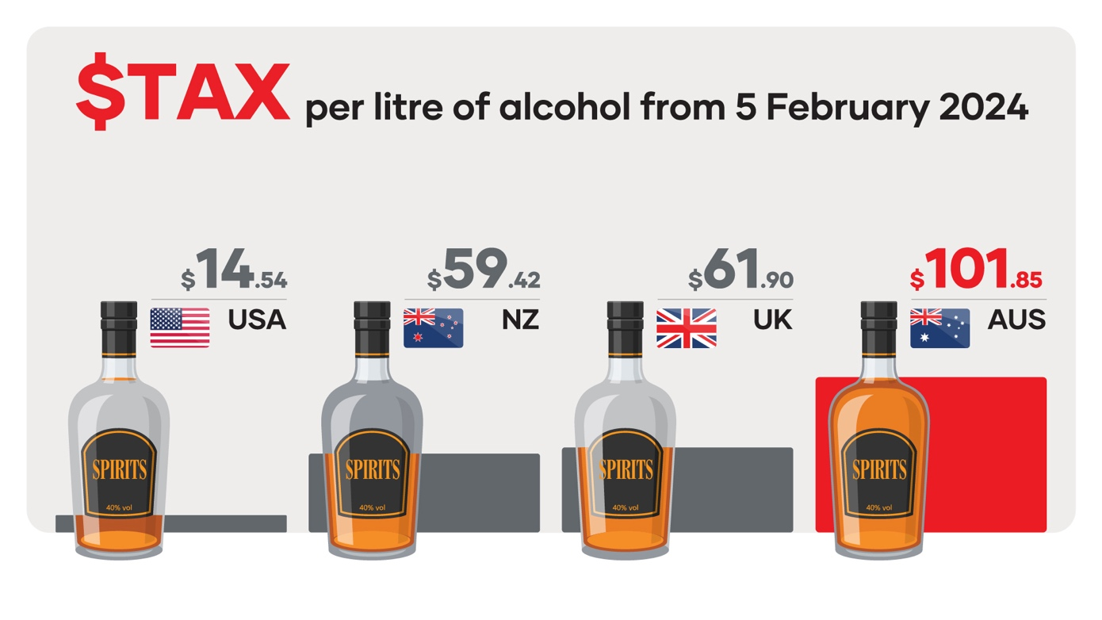
- Why don’t you just pass the excise increases on to consumers?

- Small producers do not have the market power to force these price rises through – retailers simply wouldn’t take the product.

- Australians are struggling with the cost of living. Craft spirits are becoming unaffordable, and consumers will baulk at additional price hikes.

- How much tax are consumers currently paying on spirits?

- The tax on spirits is more than double that on beer – and five times the tax on wine.

- Generic example: In a $70 bottle of gin, more than half of that price is tax ($28.52 excise + $6.36 GST)

Tax per standard drink from 5 February 2024:
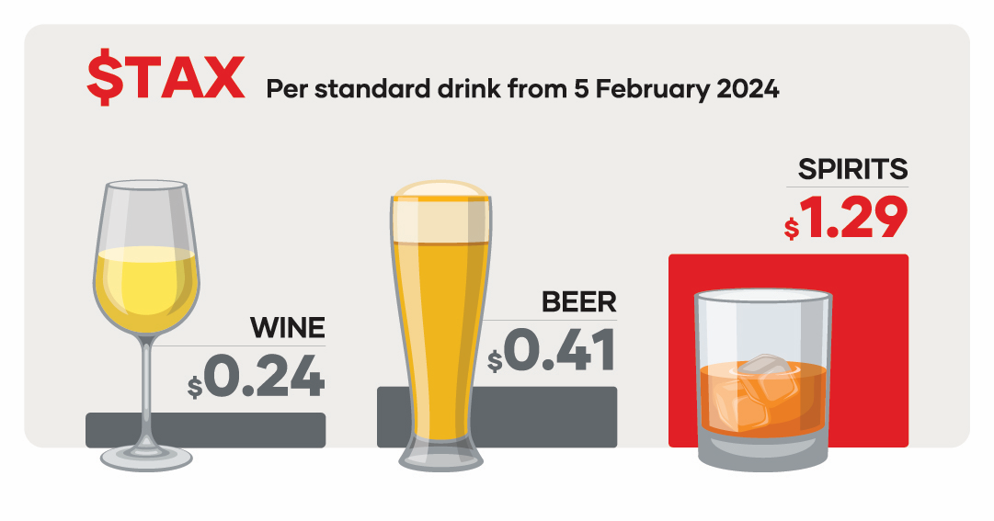

- Isn’t it true that spirits are taxed at a higher level because of its higher alcohol content, to offset the costs associated with alcohol-related harms?

- Alcohol is alcohol – the breathalyser doesn’t discriminate, nor should the tax system.

- Australian Bureau of Statistics data tells us alcohol consumption is at a 50-year low.

- The vast majority of Australians enjoy spirits responsibly, drinking less but drinking better.

- Consumption occasions are very similar to beer or wine – e.g. a gin & tonic or a whisky & coke, or the occasional cocktail.

- The disparity between tax on spirits versus beer and wine is unfair and cannot be justified.

- Consumers are increasingly savouring spirits as part of unique tourism and hospitality experiences at distillery doors and cocktail bars.
- Has the government shown any interest in reviewing the current excise regime?

- There’s been little appetite for change so far, because the regime delivers the Federal Government more than $5 billion in spirits excise revenue every year.

- However, the automatic indexation of spirits tax every six months is undermining the Government’s efforts to curb inflation. The alcohol category contributed 2.8% to the December quarter calculation of CPI.

- The Government’s constant refrain that, “this is the way it’s always been done” no longer stands up.

- The economic circumstances have changed and the current spirits industry is unrecognisable from that in 1984, when there were only two distilleries paying this tax.

- We are now at a crossroads. We either get the policy settings right to support this burgeoning industry, or tax it into oblivion.

- This excise regime is at odds with the Government’s stated aim of driving growth in manufacturing and tourism, and job creation in regional areas.

- What are you proposing?

- We’re calling on the federal government to freeze spirits excise at its current rate for two years, so we can work with them to get the policy settings right to support our long-term sustainable growth.

- Prime Minister Anthony Albanese has spoken repeatedly about growing manufacturing jobs in the regions – this is not possible with such an unsustainable tax regime.

- This industry can follow a similar growth trajectory to wine – an economic boon that will ultimately grow tax revenue while:
- Boosting jobs;
- Increasing export opportunities; and
- Allowing businesses to reinvest in their growth and attract investment to scale their operations.

Fast facts

- From 5 February 2024, Australia’s spirits tax is $101.85 per litre of alcohol.

- Australia has the third highest spirits tax in the world, behind Iceland and Norway.

- The tax on spirits is more than double that on beer – and five times the tax on wine.

- This tax is particularly bad for regional communities, because half of Australia’s 600-plus distilleries are in regional areas.

- The federal government already collects $5 billion in excise from the spirits industry in Australia per year. Compare that to wine ($1.2 billion) and beer ($2.6 billion). Why are we unfairly discriminated against?

Invite your local Member of Parliament to your distillery

Your experience and story are powerful. Sharing your story with your local Member of Parliament (MP) helps raise awareness of the impact of spirits excise on your business, customers, and the flow-on impacts to your local community.

Consider writing to your local MP, and/or inviting them to a meeting at your distillery. This meeting could also include other distillers located within your electorate.

Meeting with your local Member of Parliament is a great way to demonstrate how important it is to support the industry’s call to freeze twice-yearly CPI increases to spirits excise to support sustainable growth and investment in the Australian spirits industry.

Members of Parliament will generally only meet with their constituents. Each person has one Member of the House of Representatives (the Lower House), with twelve Senators (the Upper House) for each State and two for each Territory.

You can confirm your electorate by searching by suburb or postcode via the Australian Electoral Commission website: https://electorate.aec.gov.au/

To make the best choice about who to meet with, you can access a full list of Federal MPs and Senators online: https://www.aph.gov.au/senators_and_members/guidelines_for_contacting_senators_and_members

Depending on the position of the Member of Parliament and their various commitments including parliamentary sittings, it may be difficult for them to find a timeslot to meet with you in the short term. We recommend being patient and working closely with their staff to determine a suitable day and time to meet. Meetings would generally be no longer than 30 minutes but vary depending on the Member.

Before the meeting, we recommend:
- Contacting us immediately for a full list of distilleries in your electorate, via admin@australiandistillers.org.au
- Thinking about what you would like to share with the Member of Parliament. Write down your story and think about how you can articulate it to help them understand the impacts of the spirits excise on your business, customers, family and your local community.
- Being prepared to ask for their support to freeze spirits excise increases. Connect your personal story to why you are meeting with the Member, and why it is important that they support your ask for excise relief.
- Ask if you can be in a photo with them and if you can share it on social media with your online community. Always ask permission before taking a photo and be clear about where you would be publishing it. We recommend the following caption:
I’m meeting with my [local Member of Parliament/Senator] [Name] to seek their support to freeze spirits excise increases to facilitate sustainable growth and investment in our promising industry.
Template invitation
INSERT YOUR NAME
INSERT YOUR ADDRESS
INSERT YOUR CONTACT DETAILS
Find who your local MP is here
Find their email or address here
INSERT NAME OF MP
ADDRESS OR EMAIL OF MP
CC: admin@australiandistillers.org.au

XX February 2024

Dear [insert name of MP]

I am a distiller in your electorate and make quality Australian craft spirits products including [insert your hero products]. We are based in [insert your suburb] and employ [insert number of employees] Australians.

The Australian spirits industry is already a significant contributor to the economy, and there is enormous potential for further growth, similar to that of the hugely successful wine industry. However, the industry is held back by the Government’s lack of a comprehensive plan for a fast-growing Australian manufacturing industry, which limits the potential of producers like me to invest more, hire more and export more [delete if not relevant to your business].

On 5 February, spirits excise increased to $101.85 per litre of alcohol, due to automatic CPI increases imposed twice every year since 1984. This archaic arrangement was introduced at a time when there were only two Australian distilleries, and now adversely impacts over 600 businesses.

Our industry has consistently highlighted the adverse impacts of ongoing excise increases, and as a result, we have recommended to Government to freeze excise for two years. This modest reform provides the Government with another lever to help reduce cost-of-living pressures on hardworking Australians, whilst providing time to explore opportunities for sustainable industry development.

We believe a Parliamentary Inquiry into the Australian spirits industry will provide an opportunity to consider the best policy settings for long-term sustainable growth. We hope we can count on your support for its establishment.

You can also show your support for our distillery and the broader Australian spirits industry by:
- Visiting our distillery, so we can tell you more about the valuable contribution we make to our community, and how freezing spirits excise will help unlock our potential; and
- Writing to the Treasurer to ask that he intervenes to freeze spirits excise increases to provide immediate relief for distillers battling Australia’s highest alcohol tax.
- Writing to the Minister for Industry and Science to ask he supports our request for a Parliamentary Inquiry into the Australian spirits industry

I look forward to working with you to build a more sustainable future for the Australian spirits industry. Please contact me using the details below to coordinate your visit to our distillery.

Your sincerely,
[insert name]
Title, Distillery name
Media engagement

Spirits & Cocktails Australia and Australian Distillers has coordinated external engagement with key media in the lead up to 5 February.

If you are contacted by local media directly for your response to these stories and the latest excise increase, please refer to the talking points at the start of this document, and follow the tips and tricks below to maximise this engagement.

If you are contacted by media, please advise Australian Distillers so we can help you prepare and ensure your engagement is included when we report on the impact of our media campaign. Email media@australiandistillers.org.au

Tips and tricks

If contacted for an interview..
- respond promptly and
- find out what deadline the journalist is working towards.

Ask them how you can prepare to ensure everything runs smoothly.
- Will they be filming or photographing on the day?
- If so, it may be helpful to think about where they are best to shoot.

Ideally, we want to highlight the manufacturing and job-creation aspects of the industry.
- It would be ideal to shoot in front of distilling equipment, packaging lines etc.
- Where possible, try to include your staff actively engaged in manufacturing tasks (e.g. at the still, working with barrels, labelling bottles) or with customers (at your distillery door or bar).

Familiarise yourself with the key messages and key facts in this handbook and how they relate to your business.
- What impact is spirits tax currently having on you?
- What would you be able to do in the event of a two -year freeze? E.g. hire more staff, invest in export markets, buy more equipment etc.

If you feel like you are not being given an opportunity to deliver your messages you can use bridging techniques to respond to the question on your terms.
- For example, “I can understand where you’re coming from with that question. Let me deal with it in this way…”

Most importantly, be yourself. Local media are looking for authentic local stories, so this is an opportunity to showcase who you are and what you do.

Infographics
Share the following infographics on social media or use in other communication materials.

Access via Dropbox

Tax per litre of alcohol from 5 February 2024 - DOWNLOAD
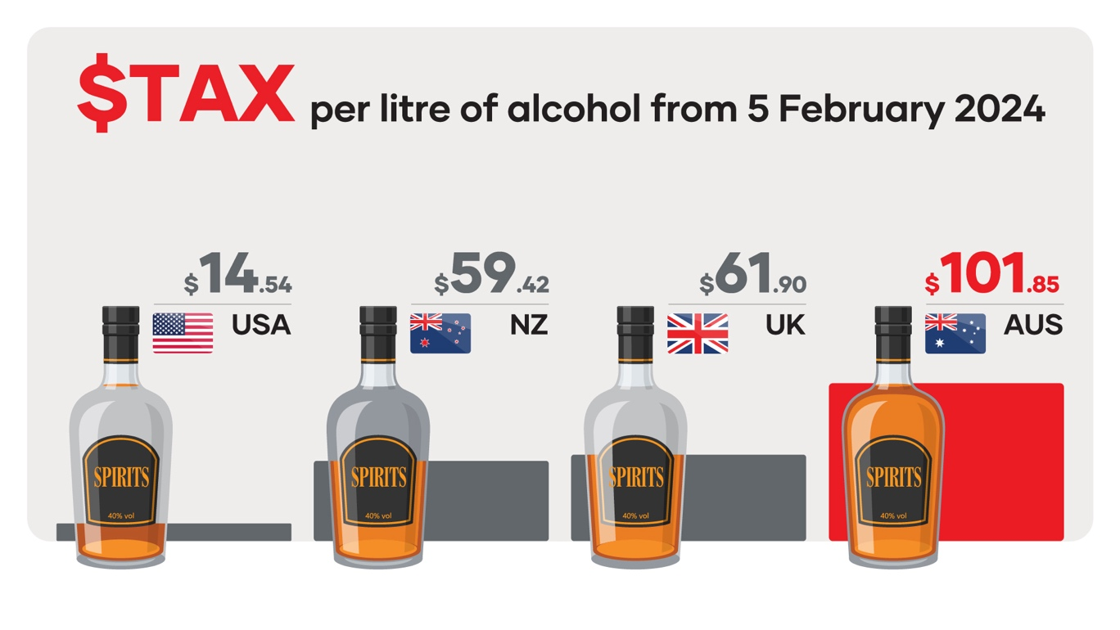

Tax per category of alcohol (from 5 February 2024) - DOWNLOAD

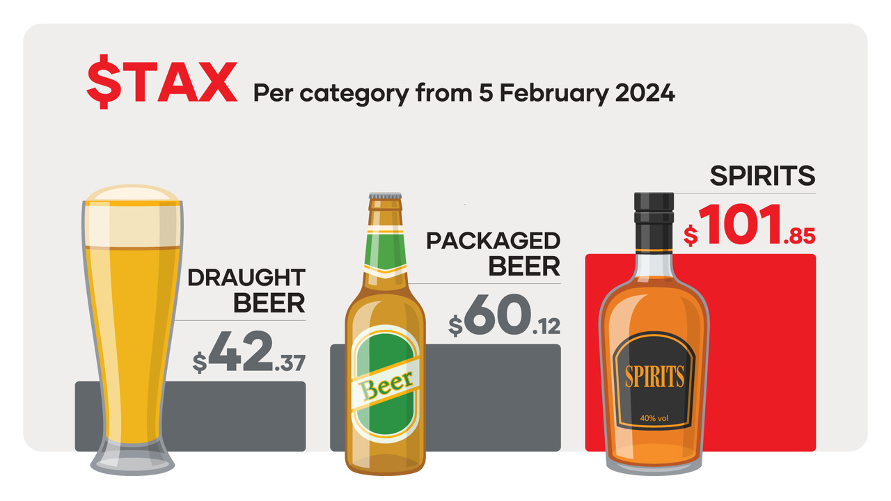

Tax per standard drink (from 5 February 2024) – DOWNLOAD

Tax revenue collected per category of alcohol – DOWNLOAD

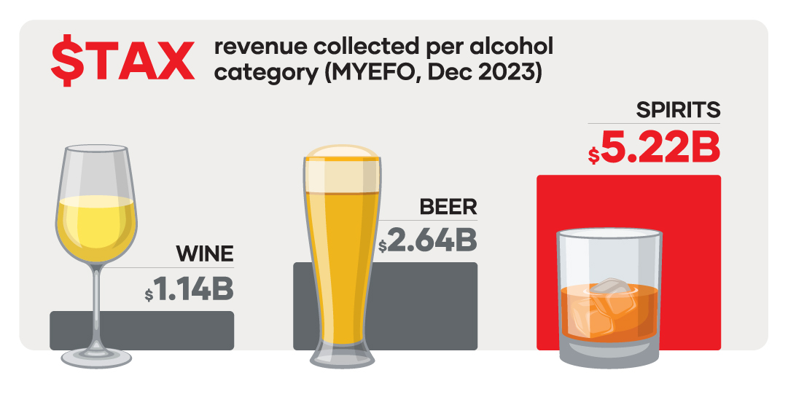

Production frontier (excise remission erosion per CPI increase) - DOWNLOAD
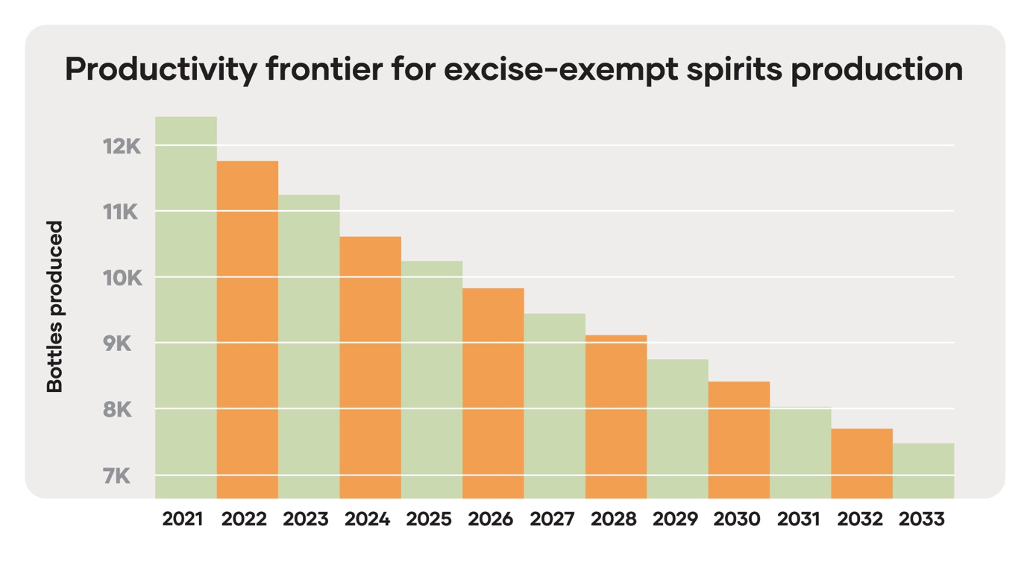

Comparison of global spirits exports per capita – DOWNLOAD

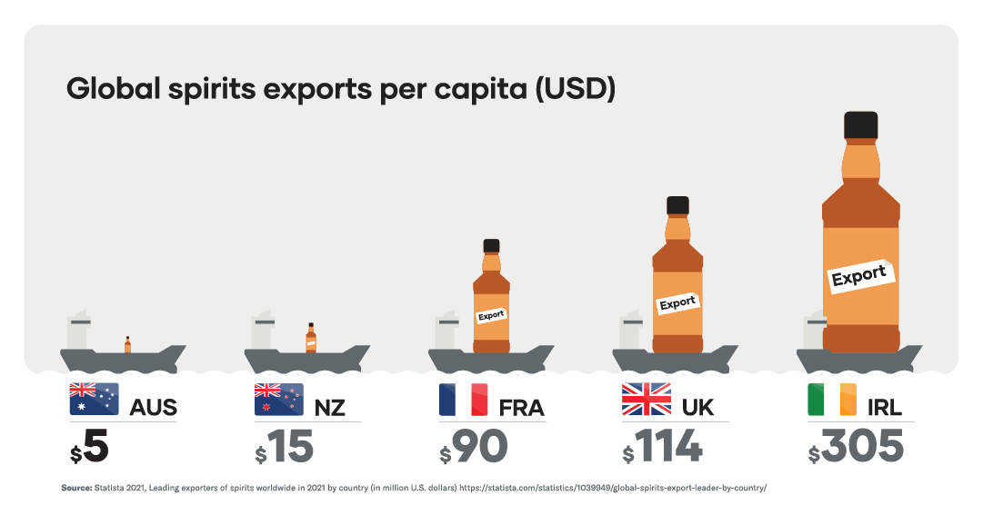

Economic contribution of the Australian spirits industry – DOWNLOAD
